LOCAL REFRESH
  - Colorado Springs, CO
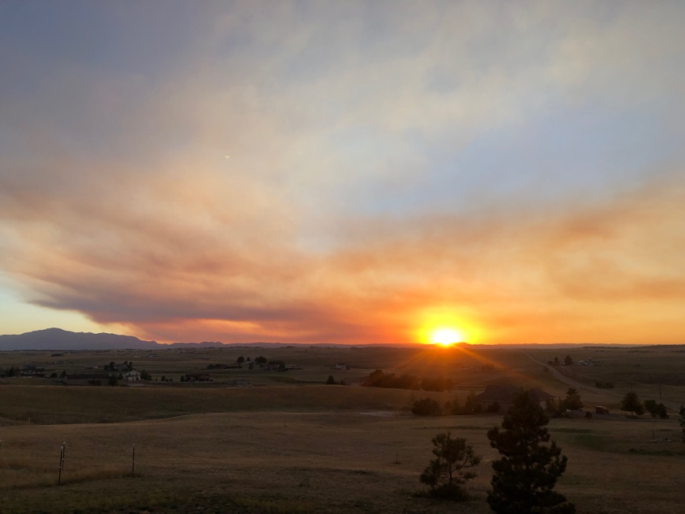
How this works:
- Referrals – If you know a missionary in desperate need of a place to REST, RECHARGE, REFRESH, please refer them. (It is important that they agree to your referral)
- Scholarships – We offer up to one week of free lodging & meals per family/group.
- Please send an email to info@ontheseventh.org with the as many of the following details
  - Full Name/s of individual or family members, along with ages (approx. will work)
  - Organization or sending church of the missionary.
  - Country or state where they reside full time/serve.
  - A brief explanation of why you believe this referral could benefit your referee.
  - Contact info for the referee & for the referrer

Once our staff has reviewed the information, we will reach out to you prior to contacting the referee.

Thank you for your partnership with us, but most of all, we appreciate your care for missionaries.

TAble of
Contents
Emphasis Heading 1 2
Heading 2 2
Heading 2 2

Emphasis
Heading 1
To get started right away, just tap any placeholder text (such as this) and start typing.

Heading 2
View and edit this document in Word on your computer, tablet, or phone. You can edit text; easily insert content such as pictures, shapes, or tables; and seamlessly save the document to the cloud from Word on your Windows, Mac, Android, or iOS device.
“Quote”
Want to insert a picture from your files or add a shape, text box, or table? You got it! On the Insert tab of the ribbon, just tap the option you need.
Find even more easy-to-use tools on the Insert tab, such as to add a hyperlink or insert a comment.

Heading 2
- Use styles to easily format your Word documents in no time. For example, this text uses the List Bullet style.
- On the Home tab of the ribbon, check out Styles to apply the formatting you want with just a tap.
 | Column Heading | Column Heading
Row Heading | Text | 123.45
Row Heading | Text | 123.45

