Global Refresh
  - Currently serving the Middle East & Uganda
*Due to Covid & Travel Restrictions, we have temporarily adjusted scholarships for one week trips to either weekend trips or Self-Care Days.
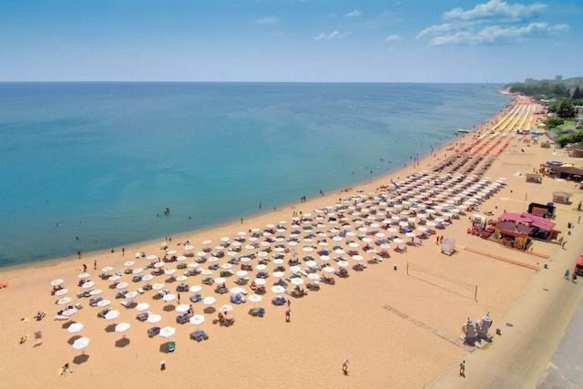
How this works:
- Referrals – If you know a global worker in desperate need of a place to REST, RECHARGE, REFRESH, please refer them. (It is important that they agree to your referral & method of contact has been approved)
- Scholarships – We offer up to one week of free lodging & meals per family/group.
- Please send an email to info@ontheseventh.org with the as many of the following details
  - Full Name/s of individual or family members, along with ages (approx. will work)
  - Organization or sending church of the missionary.
  - Country or state where they reside full time/serve.
  - A brief explanation of why you believe this referral could benefit your referee.
  - Contact info for the referee & for the referrer

Once our staff has reviewed the information, we will reach out to you prior to contacting the referee.

Thank you for your partnership with us, but most of all, we appreciate your care for missionaries.

